FR. CONCEICAO RODRIGUES COLLEGE OF ENGINEERING

Department of Computer Engineering

Course, Subject & Experiment Details

|  |  |
| --- | --- |
| Practical No: | 3 |
| Title: | To study and Implement Bare-metal Virtualization using Xen, HyperV or VMware Esxi |
| Name of the Student: | Warren Fernandes |
| Roll No: | 8940 |
| Date of Performance: | 28/03/2022 |
| Date of Submission: | 28/03/2022 |

Evaluation:

|  |  |  |
| --- | --- | --- |
| Sr. No. | Rubric | Grade |
| 1 | On time submission/completion (2) |  |
| 2 | Preparedness (2) |  |
| 3 | Skill (4) |  |
| 4 | Output (2) |  |

Signature of the Teacher

Step 1: Install Xen Server

Step i-: Insert Bootable Xen Server CD into CDROM and Step ii-: press F2 to see the advanced options,

Make first boot device as a CDROM from BIOS otherwise press Enter to start installation

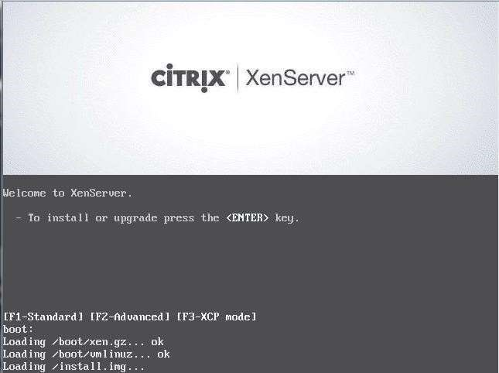 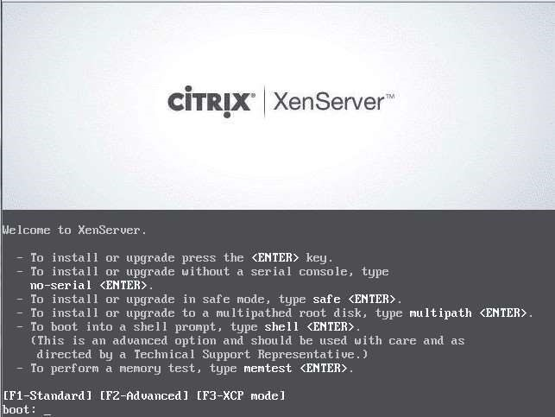

Step iii -: Select Keyboard Layout Step iv -:Press Enter to load Device Drivers

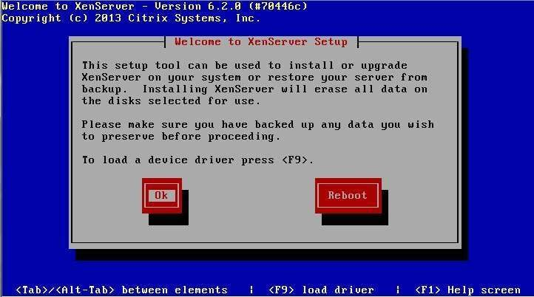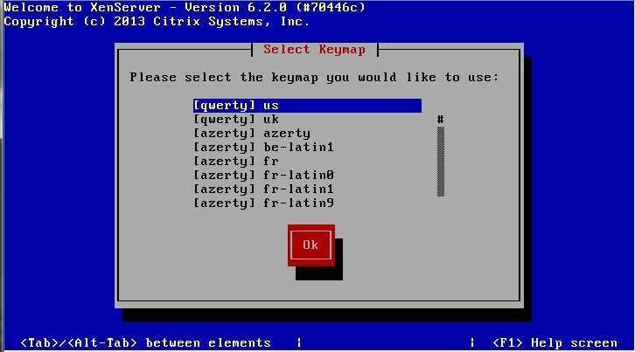

Step v -:Press Enter to Accept End user license Agreement Step vi -:Select Appropriate disk on which you want

to install Xen server

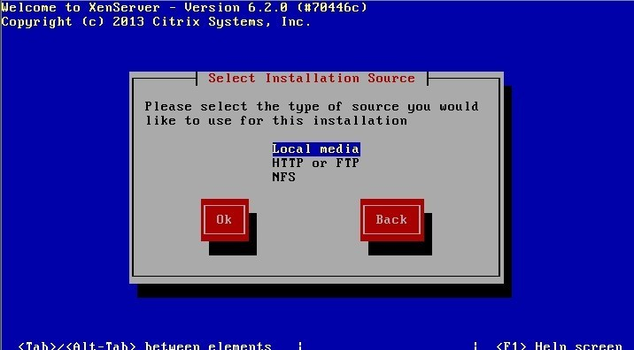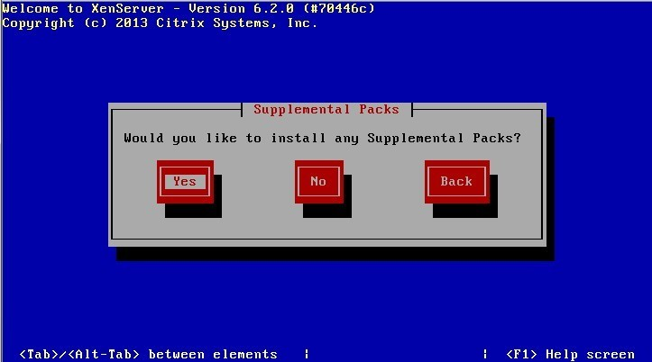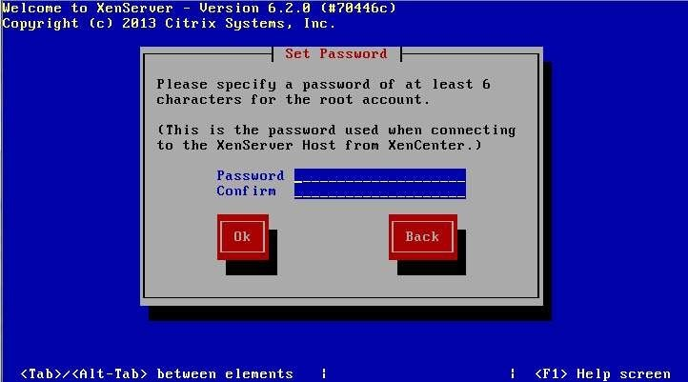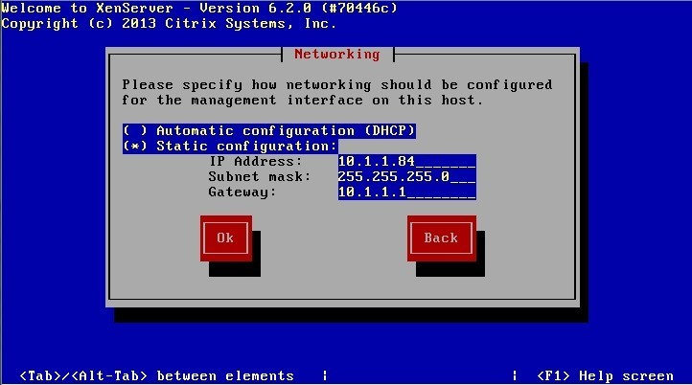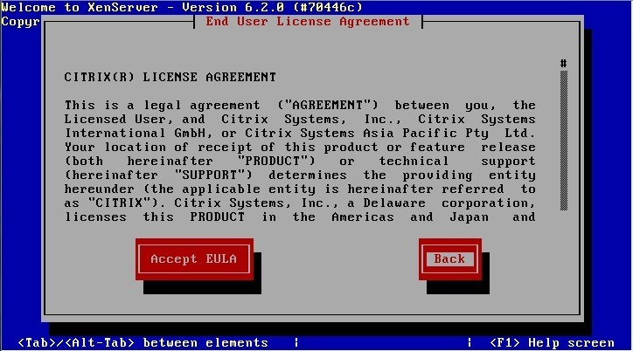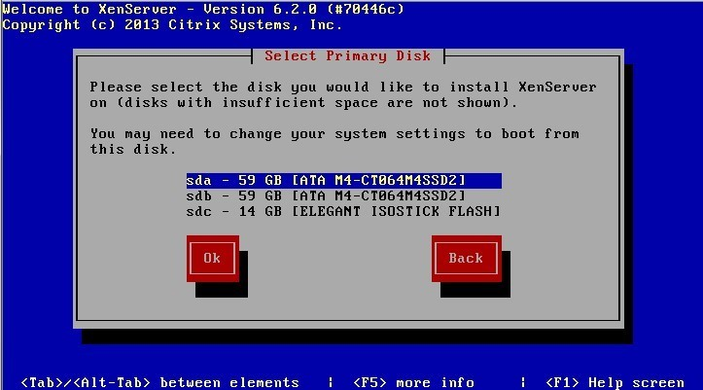

Step vii -:Select Appropriate installation Media

Step viii -:Select Additional Packages for installation

Step ix-: Specify Root password

Step x -: Specify IP Address to a Xen Server

Step xi-:Select Time Zone Step xii-:Specify NTP Servers address or use manual time entry then start installation

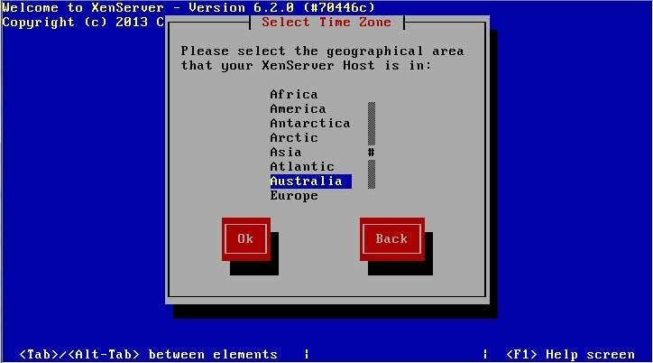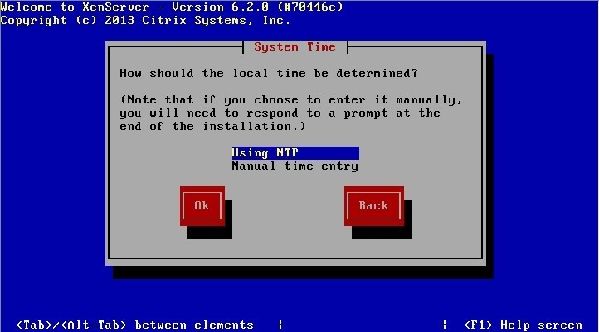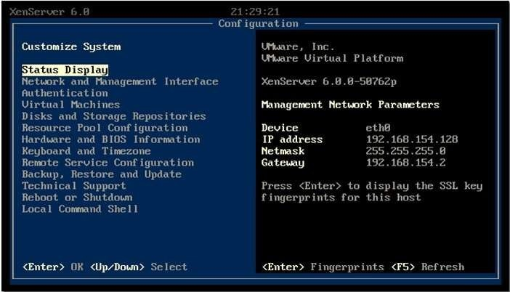

Once installation is done you will see the final screen shown below.

Xen Server Final Screenshot

Step 2:Connect Xen Server to Xen Center

Firstly, download the xen center a management utily from xen server by opening the xen severs

IP address as a URL on browser. Once Xen center is downloaded, install it.Open Xen center

from start menu of Windows.

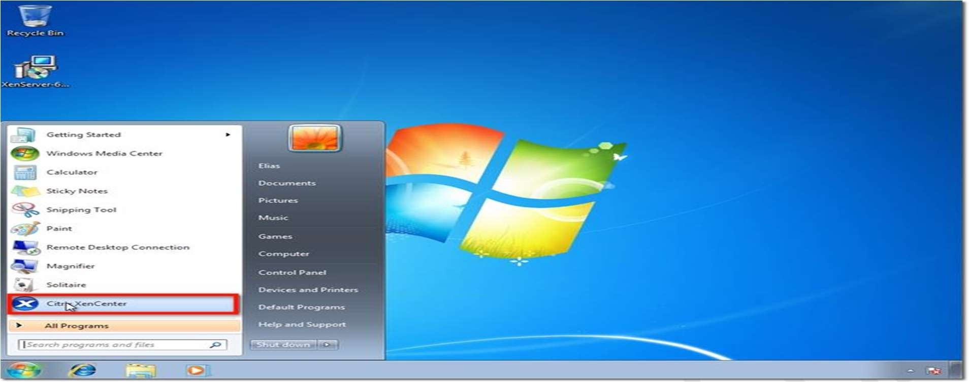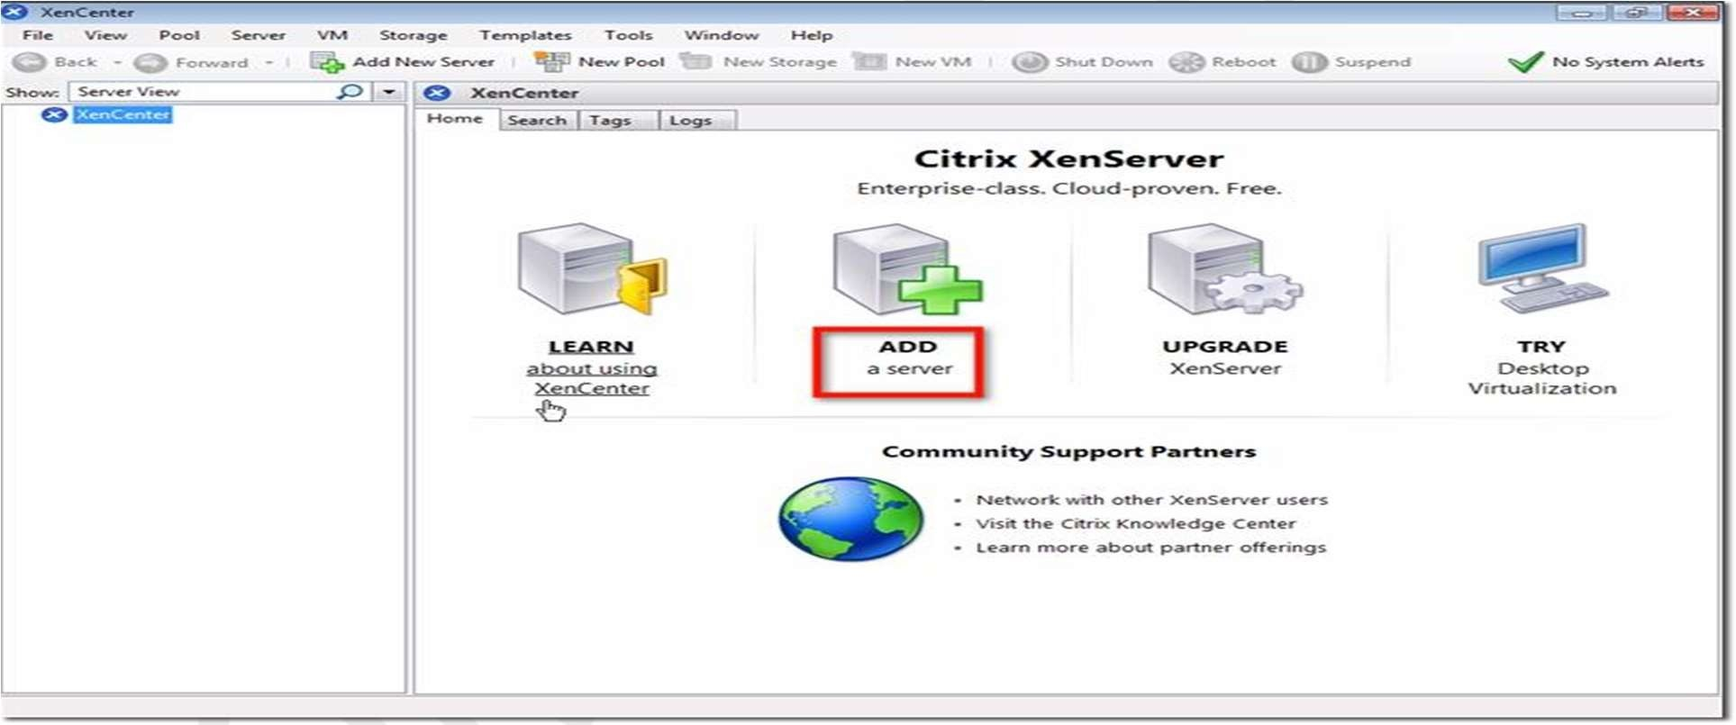

Here’s how XenCenter looks like (see screenshot below) before any hosts, resource pools, and so

on,

are

added

to

it.

To

connect

to

the

XenServer

host

you

configured

earlier,

click

Add

a

server.

Enter the IP address I asked you to take note of earlier. Also enter the password you assigned for

your

root

account.

Click

Add.

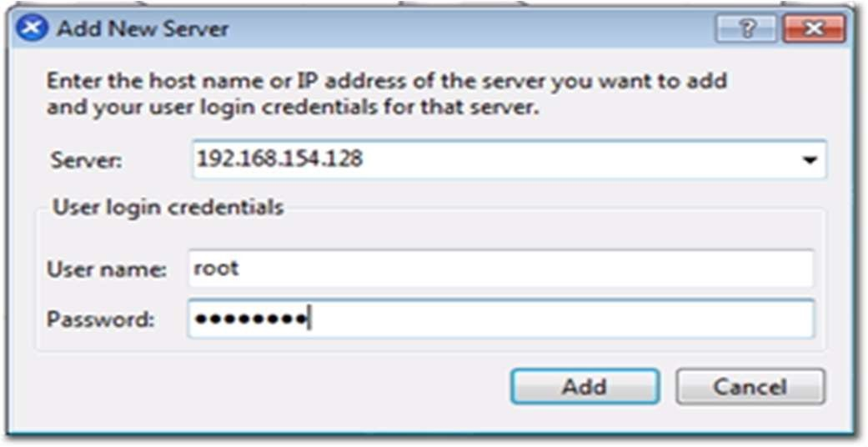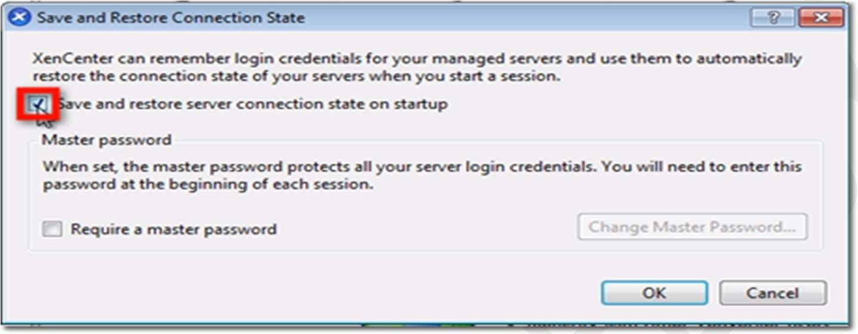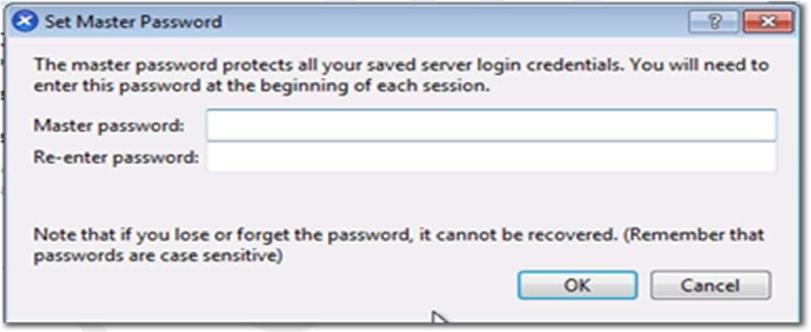

One of the first things you want to make sure as you’re adding a new XenServer to XenCenter is

to save and restore the server connection state on startup. Check the box that will do just that.

Once you do that, you will be allowed to configure a master password for all the XenServers

you’ll be associating with this XenCenter. Click the Require a master password checkbox if

that’s what you want to do, and then enter your desired master password in the fields provided.

After you click OK, you’ll be brought back to the main screen, where you’ll see your XenServer

already added to XenCenter.

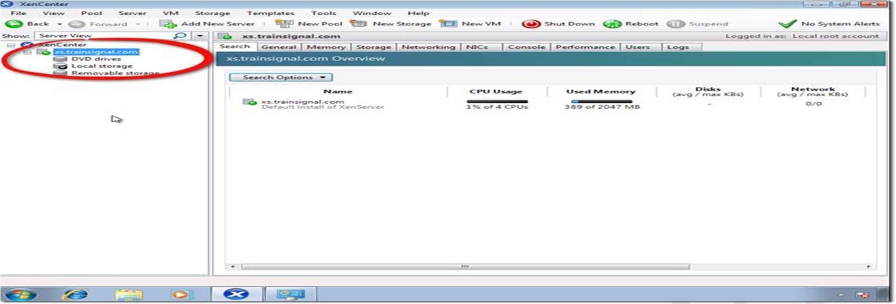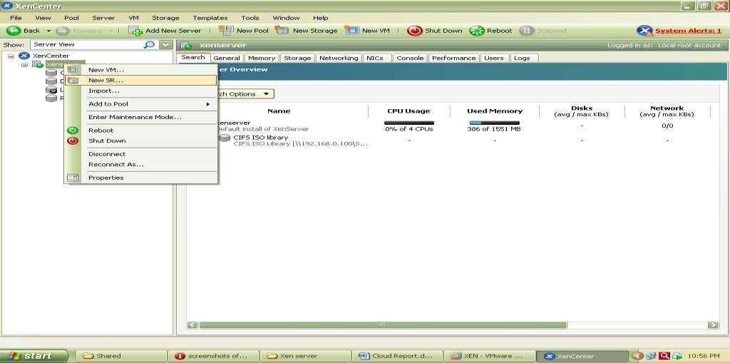

Step

-

:3

Create

Storage

Repository

and

Installing

VM

Now Before Creating VM we have to Create Storage Repository first

which is nothing but

shared directory on Xen Center which holds all iso files and which is required to install

Operating system on Xen Server its steps are as follows.Right click on Xenserver icon on xen

center and click on New SR

Now

Select

Windows

CIFS

library

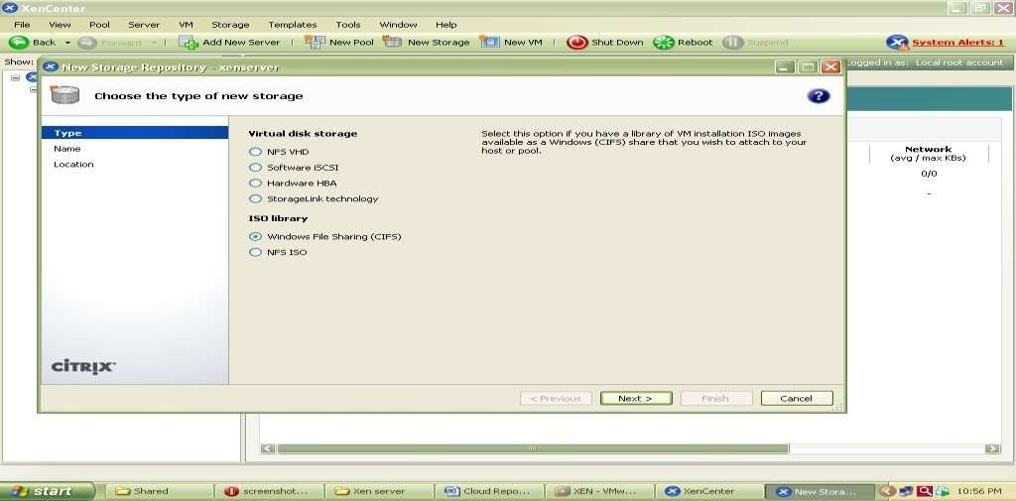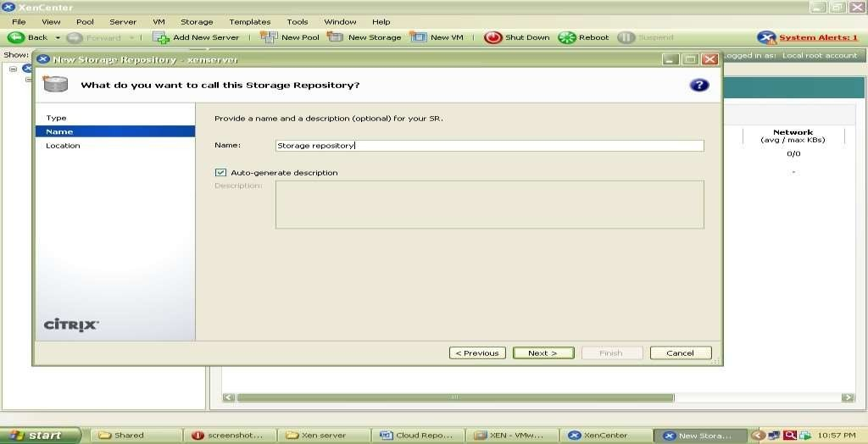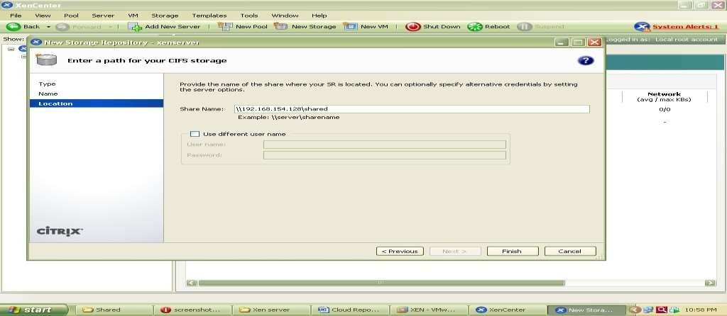

Specify Storage Repository Name

Now specify path of shared folder at client side which holds all iso files of os or VM which we

are going to install on Xen Server.

.

At the end Click on finish to create SR.

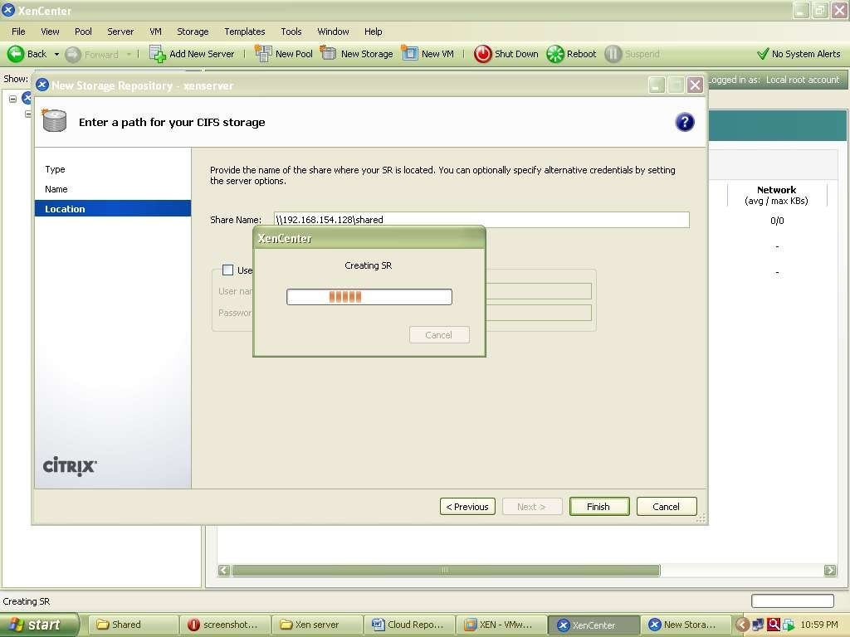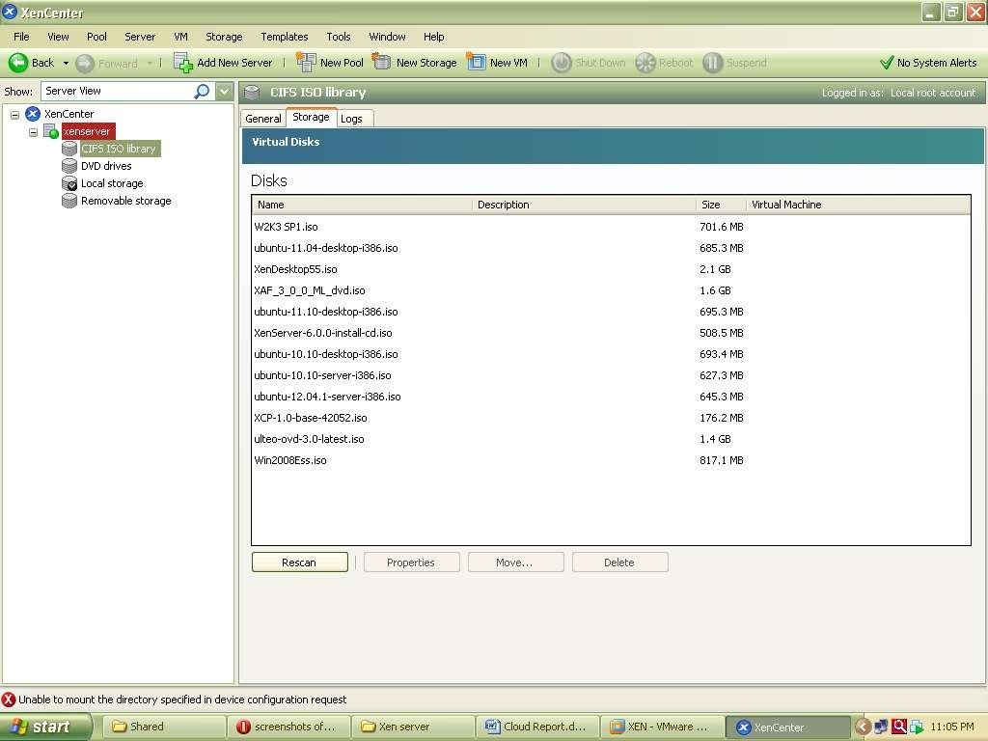

To

check

all

iso

files

click

on

CIFS

library

and

select

storage

this

will

show

you

all

iso

files.

Installation of UBUNTU Server on Xen Server

Step

1

-

:

Right

click

on

Xenserver

icon

on

xen

center

and

select

New

VM

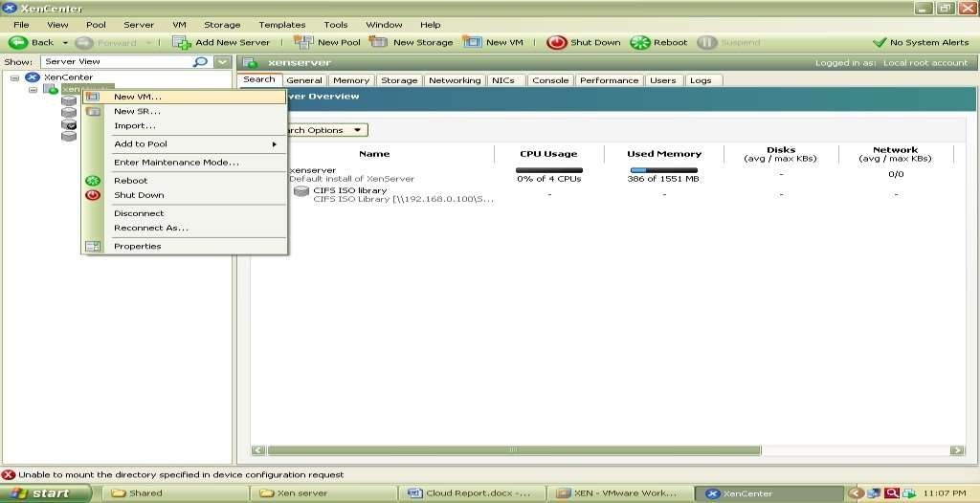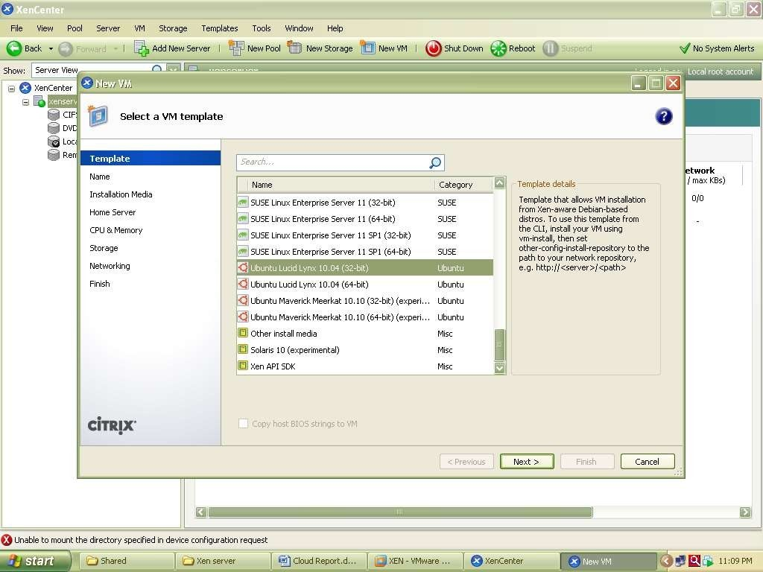

Now

select

an

Operating

System

to

be

install

here

select

Ubuntu

Lucid

Lynx

and

click

on

next

Now

specify

Instance

Name

as

ubuntu

server

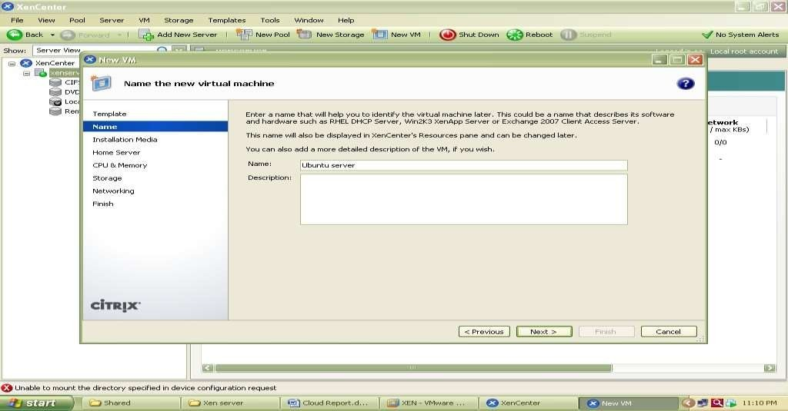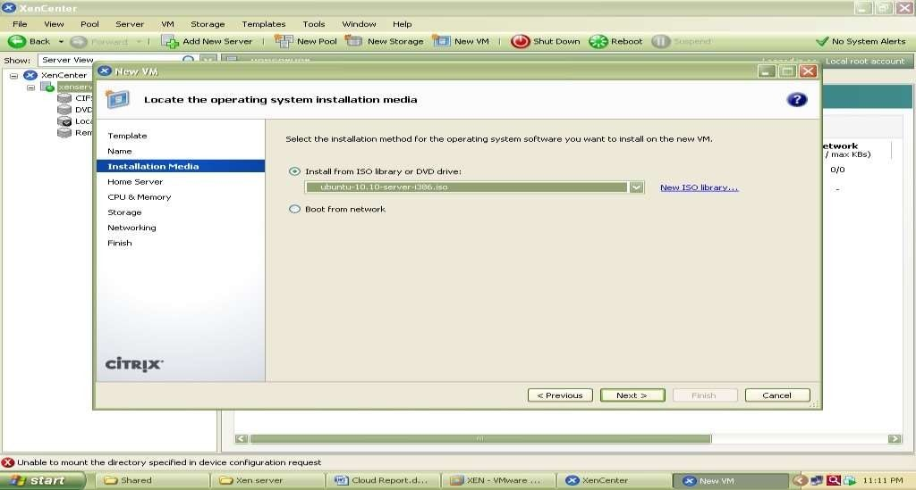

Select

iso

file

of

Ubuntu

server

10.10

to

be

install

Now

select

hardware

for

vm

i.e.

no.

of

cpu’s

and

memory

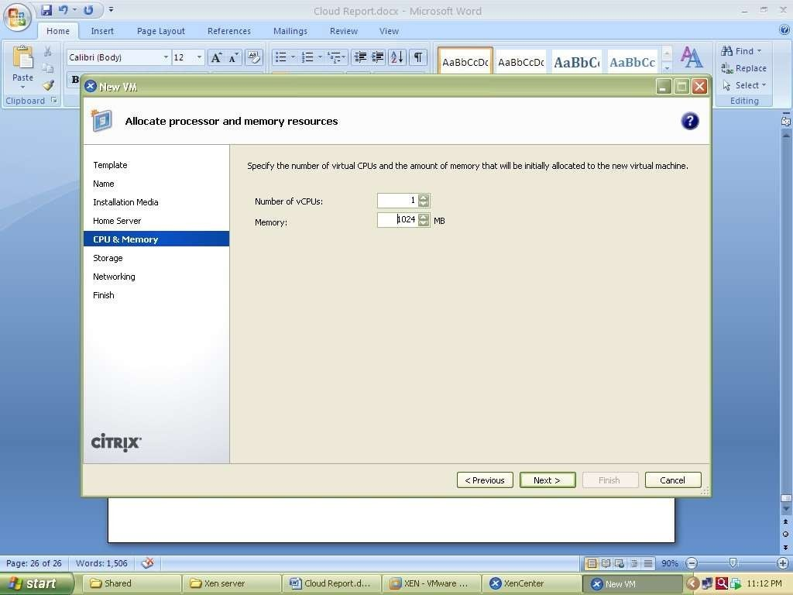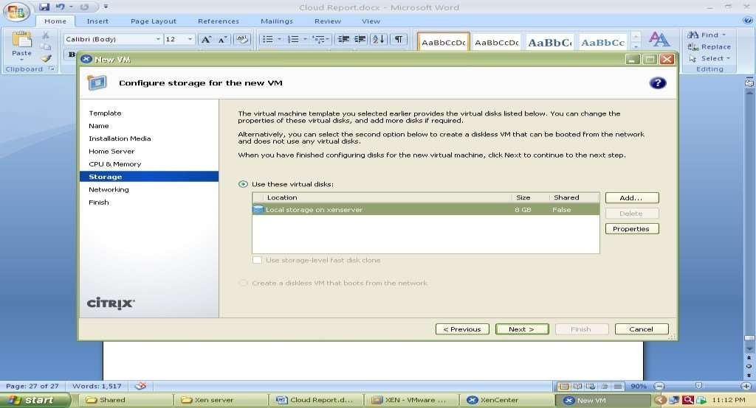

Select

local

storage

Select

network

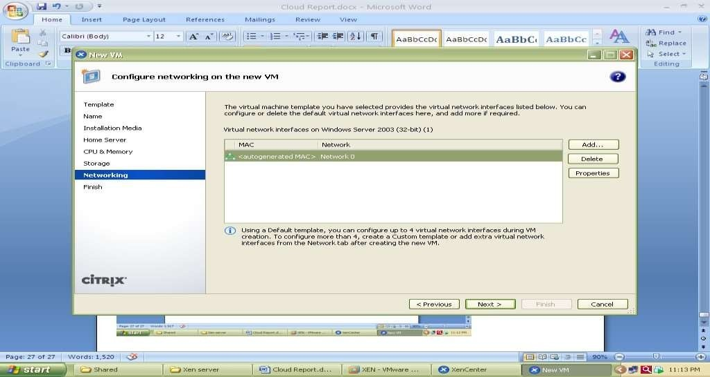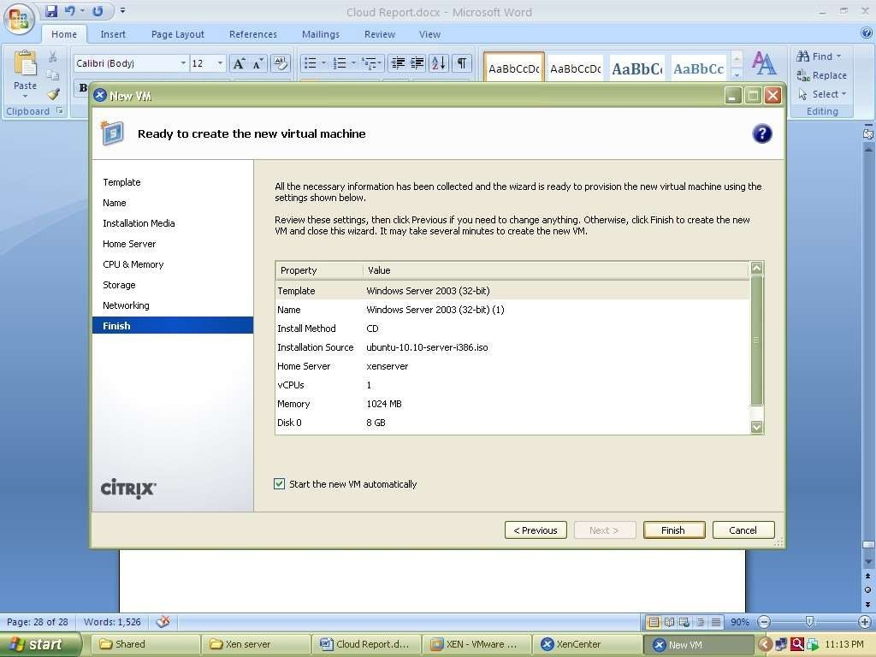

And

click

on

finish

Now

go

to

Console

tab

to

install

ubuntu

and

follow

installation

Steps.

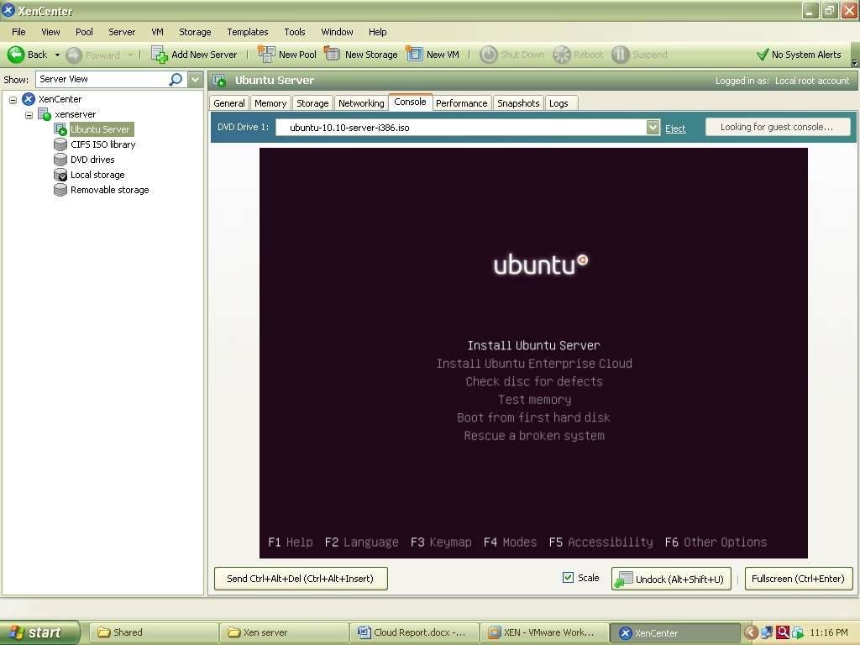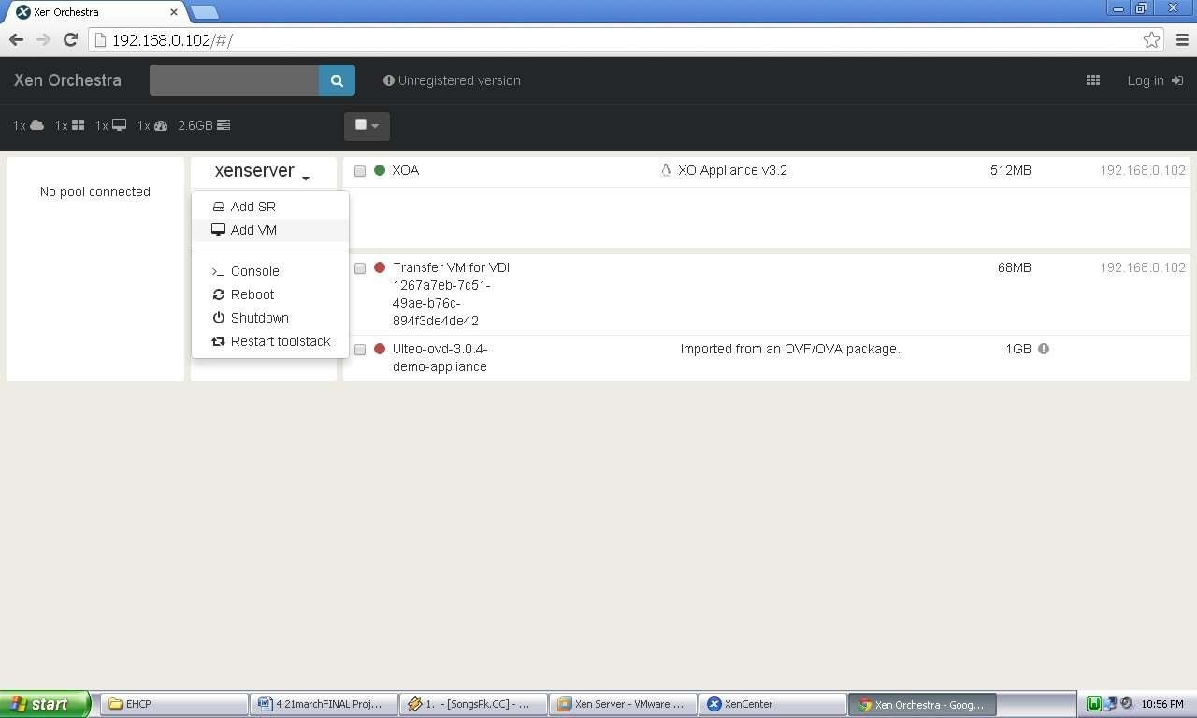

The Xen orchestra provides web based functionality of Xen Center.it provides access to all the

VMs with their lifecycle management which are installed over Xen Server shown in figure 5.28

Xen Orchestra (XOA) Portal

The Windows XP image running on Xen Orchestra over Google chrome web browser is shown in following screenshot

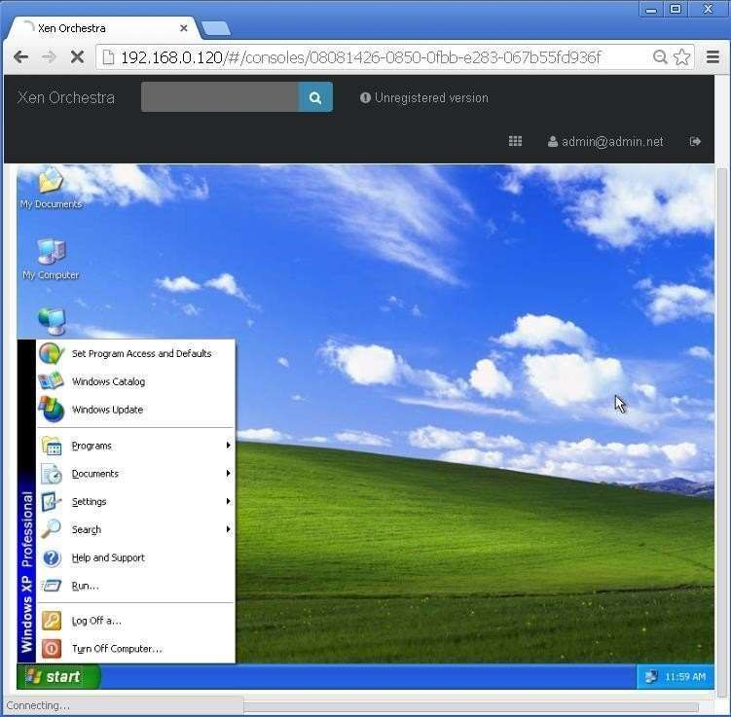

Windows XP running on Xen orchestra (XOA)

Virtualization Post Lab Questions

1. What are the basic pros and cons of virtualization?

Pros of Virtualization in Cloud Computing:

* 1. Utilization of Hardware Efficiently –

With the help of Virtualization Hardware is Efficiently used by user as well as Cloud Service Provider. In this the need of Physical Hardware System for the User is decreases and this results in less costly. In Service Provider point of View, they will vitalize the Hardware using Hardware Virtualization which decrease the Hardware requirement from Vendor side which are provided to User is decreased.

* 1. Availability increases with Virtualization –

One of the main benefits of Virtualization is that it provides advance features which allow virtual instances to be available all the times. It also has capability to move virtual instance from one virtual Server another Server which is very tedious and risky task in Server Based System. During migration of Data from one server to another it ensures its safety. Also, we can access information from any location and any time from any device.

* 1. Disaster Recovery is efficient and easy –

With the help of virtualization Data Recovery, Backup, Duplication becomes very easy. In traditional method, if somehow due to some disaster if Server system Damaged then the surety of Data Recovery is very less. But with the tools of Virtualization real time data backup recovery and mirroring become easy task and provide surety of zero percent data loss.

* 1. Virtualization saves Energy –

Virtualization will help to save Energy because while moving from physical Servers to Virtual Server’s, the number of Server’s decreases due to this monthly power and cooling cost decreases which will Save Money as well. As cooling cost reduces it means carbon production by devices also decreases which results in Fresh and pollution free environment.

* 1. Quick and Easy Set up –

In traditional methods Setting up physical system and servers are very time-consuming. Firstly,

Purchase them in bulk after that wait for shipment. When Shipment is done then wait for Setting up and after that again spend time in installing required software etc. Which will consume very time. But with the help of virtualization the entire process is done in very less time which results in productive setup.

* 1. Cloud Migration becomes easy –

Most of the companies those who already have spent a lot in the server have a doubt of Shifting to Cloud. But it is more cost-effective to shift to cloud services because all the data that is present in their server’s can be easily migrated into the cloud server and save something from maintenance charge, power consumption, cooling cost, cost to Server Maintenance Engineer etc.

Cons of Virtualization:

* 1. Data can be at Risk –

Working on virtual instances on shared resources means that our data is hosted on third party resource which put’s our data in vulnerable condition. Any hacker can attack on our data or try to perform unauthorized access. Without Security solution our data is in threaten situation.

* 1. Learning New Infrastructure –

As Organization shifted from Servers to Cloud. They required skilled staff who can work with cloud easily. Either they hire new IT staff with relevant skill or provide training on that skill which increase the cost of company.

* 1. High Initial Investment –

It is true that Virtualization will reduce the cost of companies but also it is truth that Cloud have high initial investment. It provides numerous services which are not required and when unskilled organization will try to set up in cloud they purchase unnecessary services which are not even required to them.

1. What are Intel VT/ AMD-V / hvm?

Intel VT and AMD's AMD-V are instruction set extensions that provide hardware assistance to virtual machine monitors. They enable running fully isolated virtual machines at native hardware speeds, for some workloads.

HVM (for Hardware Virtual Machine) is a vendor-neutral term often used to designate the x86 instruction set extensions.

1. How to find out If CPU Support Intel VT and AMD-V Virtualization Support?

Check if you have Intel VT-X –

* + - Use Win + S to open Start Menu search box and type System Information • Under System Summary > Processor note down the Processor name.
    - Open Intel’s product specification site.
    - Enter the number of the processor in the search box located on the right side.
    - In the processor product page, and under Advanced Technologies, check to see if Intel® Virtualization Technology (VT-x) is supported.

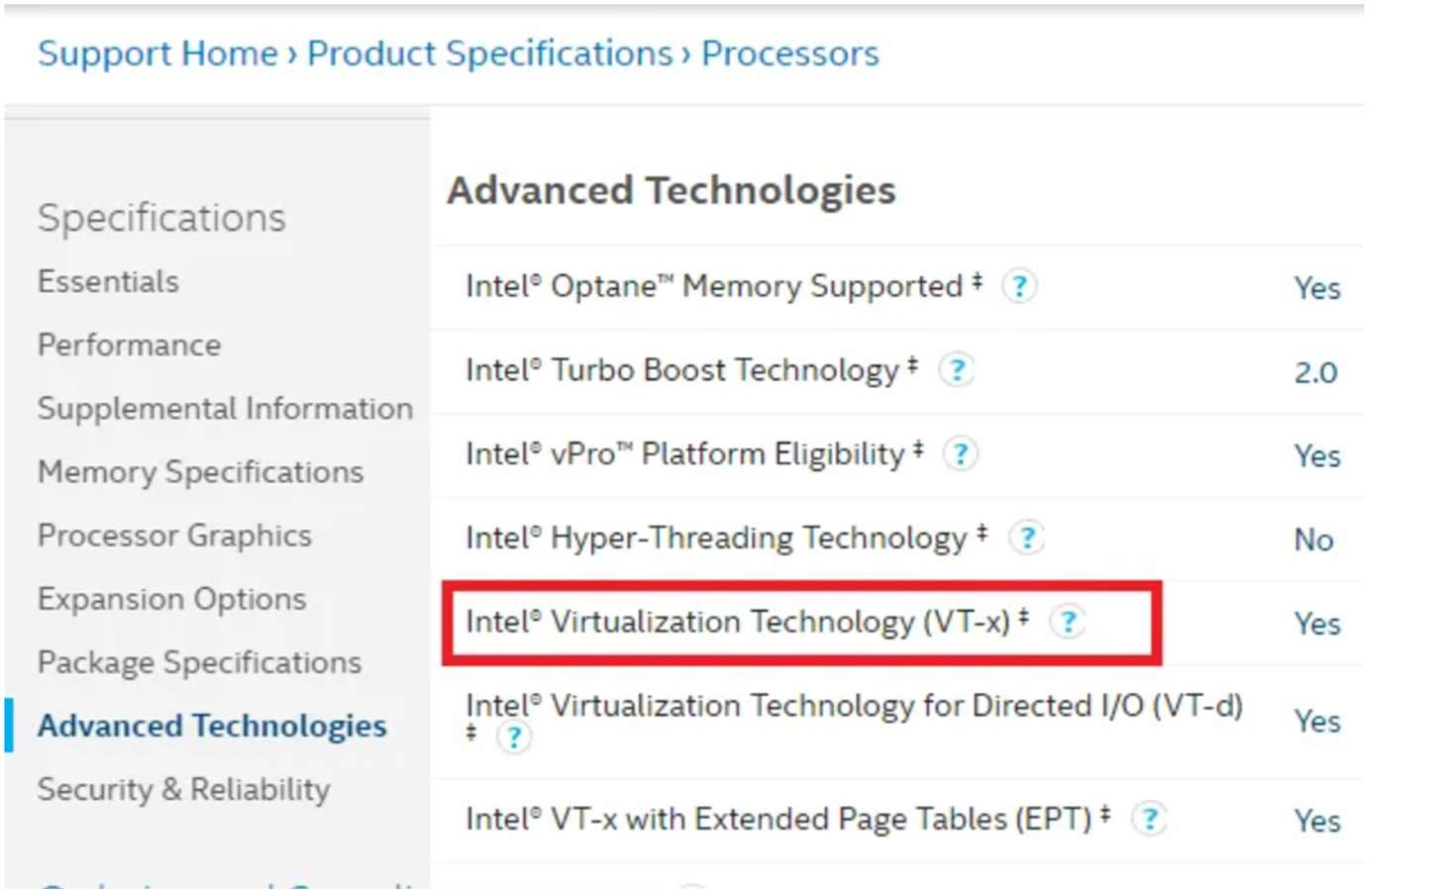

Check if you have AMD-V

It’s hard to figure this out clearly as there is no clear section on AMD website as Intel. The only utility available can check if you have Hyper V. Download and run the AMD-V with RVI Hyper V Compatibility Utility to check.

1. What is the difference between KVM and XEN?

|  |  |  |
| --- | --- | --- |
| Comparison item Xen | | KVM |
| Released 2003 | | 2007  Redhat, Ubuntu, etc. |
| Supporting enterprise | Citrix, Novell, Oracle, Ret Hat (RHEL5) and Virtual Iron |
| Supporting virtualization Full virtualization, paravirtualization technology | | Full virtualization |
| x86, IA64 and ARM from AMD, Fujitsu, IBM, Sun and other  Supporting structure companies, as well as x86/64 CPU vendors and Intel CPU embedded support | | CPU that supports virtualization |
| Supporting operating system | UNIX, Linux and Microsoft Windows | UNIX, Linux and  Microsoft Windows Support (not previously supported) |
| Live migration | stand by |
| Kernel support Need to patch the kernel | | Built-in the kernel |

1. What is the difference between KVM and VMware?

|  |  |  |
| --- | --- | --- |
| Feature | KVM | VMware vSphere |
| Hypervisor Type | Type 1 | Type 1 |
| Deployment Complexity | Difficult | Easy |
| Storage | All types of storage supported in Linux | SAS disks for local storage. VMFS, iSCSI, NFS datastores |
| Native virtual disk format | RAW(IMG), QCOW2 | VMDK |
| Raw Device Mapping | Yes. LVM is supported | Yes |
| Thin provisioning | Yes | Yes |
| Native file systems | Linux file systems, NFS | VMFS, NFS |
| VM snapshots | Yes | Yes |
| VM live migration | Yes | Yes |
| VM storage migration | Yes | Yes |
| VM Live storage migration | No | Yes |
| Clustering features | Yes (limited) | Yes (wide support) |
| High availability | Yes, with DRBD | Yes |
| Load balancing | Limited | Yes (DRS) |
| Fault Tolerance | No | Yes |
| Management  interface | Command line (virsh), KVM virt-manager | vSphere Client, Host Client, ESXCLI, PowerCLI |
| AD integration | Yes | Yes |
| Price | Free/Low (pay only for tech support) | High |
| Performance | High | High |
| Tech support | Oracle KVM, Red Hat KVM | Yes |
| Supported guest OSs | Wide | Wide |
| Networking | Virtual switch, Distributed switching, NIC bonding, link  aggregation | vSwitch, Distributed vSwitch, NIC Teaming and link aggregation, NSX |
| Firewall | Wide Linux functionality with iptables | Basic ESXi firewall or additional functionality of NSX |
| Container Integration | Yes | Yes |
| Nested  Virtualization | Yes | Yes |
| VM Linked Clones | Yes | Yes |

1. What is the difference between KVM and QEMU?

KVM - resides in the Linux kernel as a loadable module. Once loaded, KVM converts the Linux kernel into a type-1 hypervisor aka bare-metal hypervisor. KVM virtualization uses the Linux kernel as its hypervisor (VM is essentially a process). However, it depends on the Intel-VT and AMD-V virtualization extensions on Intel and AMD respectively for hardware assists to enable robust virtualization. Working in concert with these extensions, KVM helps deliver a better virtualization experience with higher throughput of almost near-zero latency. Thus, all the VMs (read process) can run without any performance or compatibility hit, as if it was running natively on a dedicated CPU. Also, because of the aforementioned extensions the VMs have a greater awareness of the capabilities of the underlying hardware platform. Therefore, is fair to say that KVM offers hardware virtualization in its sincerest and best form.

QEMU - On the other hand resides in the user space and provides system emulation including the processor and various peripherals. Typically, QEMU is deployed along with KVM as an in-kernel accelerator where KVM executes most of the guest code natively, while QEMU emulates the rest of the machine (peripherals) needed by the guest. In places where the VM has to talk to external devices, QEMU uses passthrough.